## Continuous Testing Interview Questions:

Now let’s move on to the Continuous Testing questions.

## Q1. What is Continuous Testing?

I will advise you to follow the below mentioned explanation:  
Continuous Testing is the process of executing automated tests as part of the software delivery pipeline to obtain immediate feedback on the business risks associated with in the latest build. In this way, each build is tested continuously, allowing Development teams to get fast feedback so that they can prevent those problems from progressing to the next stage of Software delivery life-cycle. This dramatically speeds up a developer’s workflow as there’s no need to manually rebuild the project and re-run all tests after making changes.

## Q2. What is Automation Testing?

Automation testing or Test Automation is a process of automating the manual process to test the application/system under test. Automation testing involves use of separate testing tools which lets you create test scripts which can be executed repeatedly and doesn’t require any manual intervention.

## Q3. What are the benefits of Automation Testing?

I have listed down some advantages of automation testing. Include these in your answer and you can add your own experience of how Continuous Testing helped your previous company:

* Supports execution of repeated test cases
* Aids in testing a large test matrix
* Enables parallel execution
* Encourages unattended execution
* Improves accuracy thereby reducing human generated errors
* Saves time and money

## Q4. How to automate Testing in DevOps lifecycle?

I have mentioned a generic flow below which you can refer to:  
In DevOps, developers are required to commit all the changes made in the source code to a shared repository. Continuous Integration tools like Jenkins will pull the code from this shared repository every time a change is made in the code and deploy it for Continuous Testing that is done by tools like Selenium as shown in the below diagram.  
In this way, any change in the code is continuously tested unlike the traditional approach.

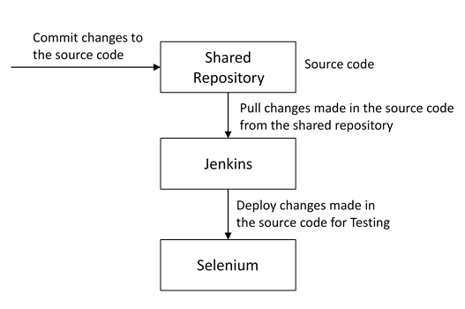

## Q5. Why is Continuous Testing important for DevOps?

You can answer this question by saying, “Continuous Testing allows any change made in the code to be tested immediately. This avoids the problems created by having “big-bang” testing left to the end of the cycle such as release delays and quality issues. In this way, Continuous Testing facilitates more frequent and good quality releases.”

## Q6. What are the key elements of Continuous Testing tools?

Key elements of Continuous Testing are:

* Risk Assessment: It Covers risk mitigation tasks, technical debt, quality assessment and test coverage optimization to ensure the build is ready to progress toward next stage.
* Policy Analysis: It ensures all processes align with the organization’s evolving business and compliance demands are met.
* Requirements Traceability: It ensures true requirements are met and rework is not required. An object assessment is used to identify which requirements are at risk, working as expected or require further validation.
* Advanced Analysis: It uses automation in areas such as static code analysis, change impact analysis and scope assessment/prioritization to prevent defects in the first place and accomplishing more within each iteration.
* Test Optimization: It ensures tests yield accurate outcomes and provide actionable findings. Aspects include Test Data Management, Test Optimization Management and Test Maintenance
* Service Virtualization: It ensures access to real-world testing environments. Service visualization enables access to the virtual form of the required testing stages, cutting the waste time to test environment setup and availability.

## Q7. Which Testing tool are you comfortable with and what are the benefits of that tool?

Here mention the testing tool that you have worked with and accordingly frame your answer. I have mentioned an example below:  
I have worked on Selenium to ensure high quality and more frequent releases.

Some advantages of Selenium are:

* It is free and open source
* It has a large user base and helping communities
* It has cross Browser compatibility (Firefox, chrome, Internet Explorer, Safari etc.)
* It has great platform compatibility (Windows, Mac OS, Linux etc.)
* It supports multiple programming languages (Java, C#, Ruby, Python, Pearl etc.)
* It has fresh and regular repository developments
* It supports distributed testing

## Q8. What are the Testing types supported by Selenium?

Selenium supports two types of testing:  
Regression Testing: It is the act of retesting a product around an area where a bug was fixed.  
Functional Testing: It refers to the testing of software features (functional points) individually.

## Q9. What is Selenium IDE?

My suggestion is to start this answer by defining Selenium IDE. It is an integrated development environment for Selenium scripts. It is implemented as a Firefox extension, and allows you to record, edit, and debug tests. Selenium IDE includes the entire Selenium Core, allowing you to easily and quickly record and play back tests in the actual environment that they will run in.  
Now include some advantages in your answer. With autocomplete support and the ability to move commands around quickly, Selenium IDE is the ideal environment for creating Selenium tests no matter what style of tests you prefer.

## Q10. What is the difference between Assert and Verify commands in Selenium?

I have mentioned differences between Assert and Verify commands below:

* Assert command checks whether the given condition is true or false. Let’s say we assert whether the given element is present on the web page or not. If the condition is true, then the program control will execute the next test step. But, if the condition is false, the execution would stop and no further test would be executed.
* Verify command also checks whether the given condition is true or false. Irrespective of the condition being true or false, the program execution doesn’t halts i.e. any failure during verification would not stop the execution and all the test steps would be executed.

## Q11. How to launch Browser using WebDriver?

The following syntax can be used to launch Browser:  
WebDriver driver = new FirefoxDriver();  
WebDriver driver = new ChromeDriver();  
WebDriver driver = new InternetExplorerDriver();

## Q12. When should I use Selenium Grid?

For this answer, my suggestion would be to give a small definition of Selenium Grid. It can be used to execute same or different test scripts on multiple platforms and browsers concurrently to achieve distributed test execution. This allows testing under different environments and saving execution time remarkably.